Prim's Spanning Tree Algorithm

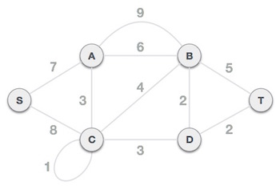

Step 1 - Remove all loops and parallel edges
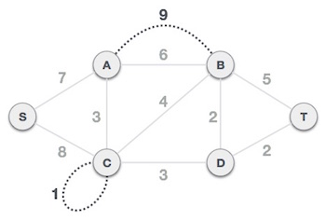
Remove all loops and parallel edges from the given graph. In case of parallel edges, keep the one which has the least cost associated and remove all others.
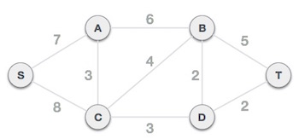

Step 2 - Choose any arbitrary node as root node
In this case, we choose S node as the root node of Prim's spanning tree. This node is arbitrarily chosen, so any node can be the root node. One may wonder why any node can be a root node. So the answer is, in the spanning tree all the nodes of a graph are included and because it is connected then there must be at least one edge, which will join it to the rest of the tree.

Step 3 - Check outgoing edges and select the one with less cost
After choosing the root node S, we see that S,A and S,C are two edges with weight 7 and 8, respectively. We choose the edge S,A as it is lesser than the other.
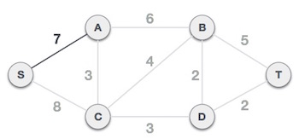
Now, the tree S-7-A is treated as one node and we check for all edges going out from it. We select the one which has the lowest cost and include it in the tree.
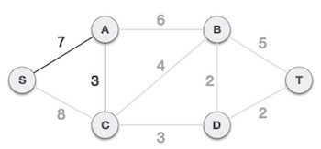
After this step, S-7-A-3-C tree is formed. Now we'll again treat it as a node and will check all the edges again. However, we will choose only the least cost edge. In this case, C-3-D is the new edge, which is less than other edges' cost 8, 6, 4, etc.
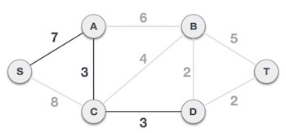
After adding node D to the spanning tree, we now have two edges going out of it having the same cost, i.e. D-2-T and D-2-B. Thus, we can add either one. But the next step will again yield edge 2 as the least cost. Hence, we are showing a spanning tree with both edges included.

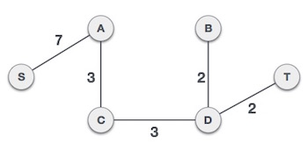

The time complexity of the prim's algorithm is O(E logV) or O(V logV), where E is the no. of edges, and V is the no. of vertices.

Workout example
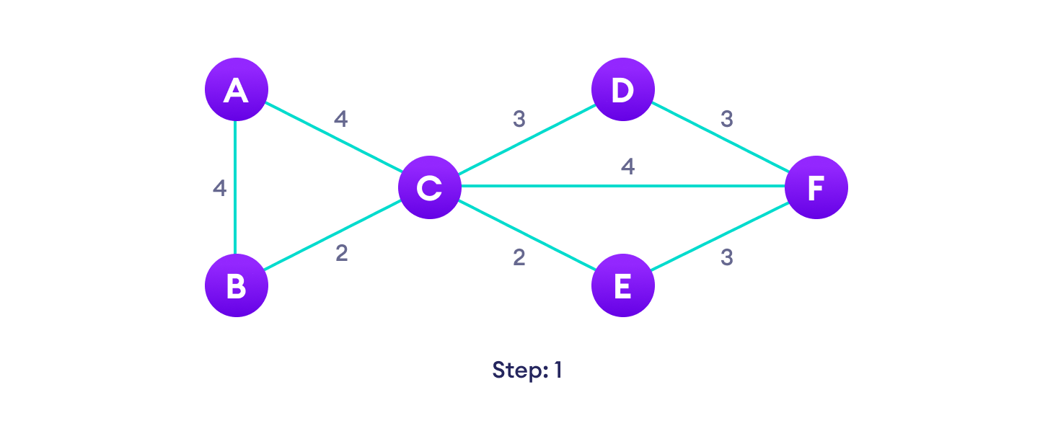

Implementation of Prim's algorithm
- #include <stdio.h>
- #include <limits.h>
- #define vertices 5 /*Define the number of vertices in the graph*/
- /* create minimum_key() method for finding the vertex that has minimum key-value and that is not added in MST yet */
- int minimum_key(int k[], int mst[])
- {
- int minimum = INT_MAX, min,i;

- /*iterate over all vertices to find the vertex with minimum key-value*/
- for (i = 0; i < vertices; i++)
- if (mst[i] == 0 && k[i] < minimum )
- minimum = k[i], min = i;
- return min;
- }
- /* create prim() method for constructing and printing the MST.
- The g[vertices][vertices] is an adjacency matrix that defines the graph for MST.*/
- void prim(int g[vertices][vertices])
- {
- /* create array of size equal to total number of vertices for storing the MST*/
- int parent[vertices];
- /* create k[vertices] array for selecting an edge having minimum weight*/
- int k[vertices];
- int mst[vertices];
- int i, count,edge,v; /*Here 'v' is the vertex*/
- for (i = 0; i < vertices; i++)
- {
- k[i] = INT_MAX;
- mst[i] = 0;
- }
- k[0] = 0; /*It select as first vertex*/
- parent[0] = -1; /* set first value of parent[] array to -1 to make it root of MST*/
- for (count = 0; count < vertices-1; count++)
- {
- /*select the vertex having minimum key and that is not added in the MST yet from the set of vertices*/
- edge = minimum_key(k, mst);
- mst[edge] = 1;
- for (v = 0; v < vertices; v++)
- {
- if (g[edge][v] && mst[v] == 0 && g[edge][v] < k[v])
- {
- parent[v] = edge, k[v] = g[edge][v];
- }
- }
- }
- /*Print the constructed Minimum spanning tree*/
- printf("\n Edge \t Weight\n");
- for (i = 1; i < vertices; i++)
- printf(" %d <-> %d %d \n", parent[i], i, g[i][parent[i]]);

- }
- int main()
- {
- int g[vertices][vertices] = {{0, 0, 3, 0, 0},
- {0, 0, 10, 4, 0},
- {3, 10, 0, 2, 6},
- {0, 4, 2, 0, 1},
- {0, 0, 6, 1, 0},
- };
- prim(g);
- return 0;
- }

